A STUDY ON THE EFFECTIVENESS OF AN AUTOMATED TESTING TOOL
By
MOHANAPRIYA.L
Roll No: 1926MBA0112
Reg. No: 68319200027
A PROJECT REPORT
Submitted to the
FACULTY OF MANAGEMENT SCIENCES
in partial fulfillment for the award of the degree
of
MASTER OF BUSINESS ADMINISTRATION
in
TECHNOLOGY MANAGEMENT


CENTRE FOR DISTANCE EDUCATION
ANNA UNIVERSITY
CHENNAI 600 025
MARCH, 2022

BONAFIDE CERTIFICATE
Certified that the Project report titled “A STUDY ON THE EFFECTIVENESS OF AN AUTOMATED TESTING TOOL” is the bonafide work of Ms. MOHANAPRIYA.L who carried out the work under my supervision. Certified further that to the best of my knowledge the work reported herein does not form part of any other project report or dissertation on the basis of which a degree or award was conferred on an earlier occasion on this or any other candidate.

Signature of Student Signature of Guide

Name: MOHANAPRIYA.L Name: Dr. NADANASABAI
Roll No.: 1926MBA0112 Designation: ASSOCIATE PROFESSOR
Reg. No.: 68319200027 Address: ST JOSEPH’S COLLEGE OF ENGINEERING

CERTIFICATE OF VIVA-VOICE EXAMINATION

This is to certify that Ms. MOHANAPRIYA.L (Roll No. 1926MBA0112; Register No. 68319200027) has been subjected to Viva-voice-Examination on ……………. at ………………… at the Study Centre ……………………………………………………………

Internal Examiner External Examiner
Name: Name:
Designation: Designation:
Address: Address:

Coordinator
Study Centre
Name:
Designation:
Address:

Date:

ABSTRACT
Manual testing is very time-consuming. Regression testing has to be done to ensure that changes in one portion of the software have no ill effects on other portions of the software. The entire testing process needs to be repeated whenever a change is made to any portion of the software.
To test a Client/Server application, the client software has to be run on different machines and one person has to test each client application to test the performance of the software when multiple users use the same software simultaneously. On the other hand, automated tools facilitate running the software from a single client machine, resulting in savings in terms of infrastructure and manpower.
The Stratified random sampling method has been used in the research work. Multiple-choice questions have been chosen to collect the responses from 127 employees. Percentage analysis has been used to interpret the collected data. The data collected has been analyzed through statistical tools like Karl Pearson’s Correlation, Chi-square test. Numerous new findings have been derived from this research has helped to provide a few suggestions to increase the company's productivity by improving the automated testing tool.

ACKNOWLEDGEMENT
I would like to express my sincere gratitude to my guide Dr. R. Nadanasabai and our Co-Ordinator Dr. Meenakurmari for guiding me through every phase of the project and for extending the facilities of the department towards the project and for his involvement and benevolent support.
I express my sincere thanks to the faculty members of Department of Management Studies for instilling confidence in me to carry out this study and extending valuable guidance and encouragement from time to time. It is also my great pleasure to thank my family and friends, without whose co-operation and support, it would have not been possible to complete the project on time.

MOHANAPRIYA.L

TABLE OF CONTENTS

CHAPTERS | TITLE | PAGE NO
 | BONAFIDE CERTIFICATE | ii
 | CERTIFICATE OF VIVA VOICE EXAMINATION | iii
 | ABSTRACT | iv
 | ACKNOWLEDGEMENT | v
 | TABLE OF CONTENT | vi
 | LIST OF TABLES | vii
 | LIST OF FIGURES | viii
CHAPTER I | INTRODUCTION
1.1 | INTRODUCTION | 1
1.1.1 | RESEARCH BACKGROUND | 12
1.1.2 | IDENTIFICATION PROBLEM | 13
1.2 | INDUSTRY PROFILE | 13
1.3 | COMPANY PROFILE | 14
1.4 | NEED FOR THE STUDY | 15
1.5 | SCOPE OF THE STTUDY | 15
1.6 | OBJECTIVES OF THE STUDY | 16
1.7 | LIMITATIONS OF THE STUDY | 16
CHAPTER II | LITERATURE SURVEY
2.1 | REVIEW OF LITERATURE | 17
CHAPTER III | RESEARCH METHODOLOGY
3.1 | RESEARCH METHODOLOGY | 20
3.1.1 | RESEARCH DESIGN | 21
3.2 | SAMPLE SIZE | 21
3.3 | DATA SOURCES | 21
3.4 | RESEARCH INSTRUMENTS | 22
3.5 | SAMPLING | 22
3.6 | SAMPLING FRAME | 22
3.7 | SAMPLE DESIGN | 22
3.9 | ANALYTICAL TOOLS | 23
CHAPTER IV | DATA ANALYSIS AND INTERPRETATION
4.1 | DATA ANALYSIS AND INTERPRETATION | 13
4.2 | STATISTICAL TOOLS | 32
CHAPTER V | CONCLUSIONS
5.1 | FINDINGS | 35
5.2 | SUGGESTIONS | 35
5.3 | CONCLUSION | 39
 | ANNEXURE
 | QUESTIONNAIRE | 40
 | BIBLIOGRAPHY | 44
 | REFERENCES | 44

LIST OF TABLES
TABLE NO. | TITLE | PAGE NO
4.6 | DO YOU PREFER AUTOMATION | 14
4.7 | WHEN DO YOU PREFER MANUAL TESTING OVER AUTOMATION TESTING | 15
4.8 | WHAT FACTORS DETERMINE THE EFFECTIVENESS OF AUTOMATION TESTING | 17
4.9 | MORE DEFECTS ARE IDENTIFIED IN WHICH LEVEL OF TESTING | 19
4.10 | CAN YOU ACHIEVE 100% IN AUTOMATION | 20
4.11 | HOW DO YOU DECIDE WHICH TOOL YOU HAVE TO USE | 21
4.12 | WHAT KIND OF TEST DO YOU THINK SHOULD NOT BE USED | 23
4.15 | IDENTIFICATION OF DEFECTS CONCERNING DATA PRIVACY AND SECURITY IS HIGHLY IMPORTANT WHILE TESTING | 26
4.19 | DIFFERENT STAGES IN SOFTWARE TESTING IS HELPFUL IN THE DETECTION OF DEFECTS | 28
4.23 | PROCESS IMPROVEMENT OF THE USERS IS THE MAJOR GOAL OF AUTOMATION TESTING | 29
4.24 | ENHANCED SECURITY OF THE PROCESS HAS TO BE MAINTAINED DURING AUTOMATION TESTING | 29

LIST OF FIGURES
TABLE NO. | TITLE | PAGE NO
4.6 | DO YOU PREFER AUTOMATION | 14
4.7 | WHEN DO YOU PREFER MANUAL TESTING OVER AUTOMATION TESTING | 15
4.8 | WHAT FACTORS DETERMINE THE EFFECTIVENESS OF AUTOMATION TESTING | 18
4.9 | MORE DEFECTS ARE IDENTIFIED IN WHICH LEVEL OF TESTING | 19
4.10 | CAN YOU ACHIEVE 100% IN AUTOMATION | 20
4.11 | HOW DO YOU DECIDE WHICH TOOL YOU HAVE TO USE | 21
4.12 | WHAT KIND OF TEST DO YOU THINK SHOULD NOT BE USED | 23
4.15 | IDENTIFICATION OF DEFECTS CONCERNING DATA PRIVACY AND SECURITY IS HIGHLY IMPORTANT WHILE TESTING | 26
4.19 | DIFFERENT STAGES IN SOFTWARE TESTING IS HELPFUL IN THE DETECTION OF DEFECTS | 28
4.23 | PROCESS IMPROVEMENT OF THE USERS IS THE MAJOR GOAL OF AUTOMATION TESTING | 29
4.24 | ENHANCED SECURITY OF THE PROCESS HAS TO BE MAINTAINED DURING AUTOMATION TESTING | 29

CHAPTER 1
1.1 INTRODUCTION
Software testing is an area of software development where persistence and continuous efforts are critically essential. Software testing is the process of verifying software quality by using the software with applicable test cases to determine if proposed software requirements are being met properly. Testing is a fundamental aspect of software engineering, but it is a practice that too often is easily forgotten in today’s fast-paced Web application development environment.
Web applications are being changed both in terms of technology and functionality. Testing applications thoroughly and efficiently is necessary for deployment when wanting to retain existing customers and also fetch in new customers and clients. Testing is really important because software reliability is defined using testing and test effectiveness, approximately fifty percent of the software development budget for software projects is being spent on testing, and this is average in the industry.
Software testing is an expensive effort as the entire cycle needs to be carried out as frequently as the build is rolled out. Therefore, there is a need to reduce testing dependency on humans. Software testing is necessary and inevitable because errors are often introduced into software Inadvertently as it is designed, coded, and developed. The software has become complex today, which means there are many lines of code, and as a result, more cycles of testing need to be done.
Reduces Repetitive Tasks which is the Primary Benefit of Automation Testing. When tested manually, Software Tests repeat several times to ensure quality. Increases Coverage. Comprehensive Testing, especially Regression Testing requires a wide test coverage. A wide coverage helps to check the application on every platform and device. Test Automation helps in Performance Testing. Manual Testers can conduct Performance Testing. But they conduct in a controlled environment and are considered impossible. Automation Testing equals Reusability. Over a period of automating codes for different tasks, automated testing tools creates a library of reusable scripts.

1.1.1 RESEARCH BACKGROUND

­­Several IT solution providers are now kicking the tires on Test Automation, as a critical enabler of Continuous Delivery and software development. Bringing test automation into the fold of development and rollout processes provides a set of repeatable checks which are run on an ongoing basis before any package gets shipped. With automated checks being carried out regularly around your regression, performance, and acceptance scenarios, you can reduce the number of escaped bugs- and rev up the delivery of new applications, improving your relationship with customers. Greater automation coverage gives stakeholders more accurate information around risk to high-value features, ensuring they are able to make more informed decisions at the business level.
In general, it allows for better management of, among other things, the release of software updates, the porting of new code, and the overall processing environment. Many organizations that were “born digital” are now extensively leveraging test automation in order to roll back failures in a matter of seconds, enabling fixes to be made on a constant basis, and significantly mitigating business risk. Many market-leading companies even choose not to release features unless at least 80 percent of the code is covered by automated testing, according to Mckinsey.
Product teams can thus understand and make decisions quickly based on automation results that impact performance and customer experience. When it comes to testing leaders among traditional enterprises, customer-facing systems such as e-commerce websites or mobile applications usually represent the greatest priority for automated testing. Since these systems go through frequent innovation, it becomes important to streamline the product testing through sophisticated automation- aiming, for instance, to verify an end-to-end customer journey as part of a larger initiative to digitize customer processes.
So, it is now established that test automation improves the software delivery process significantly and conveys a number of critical advantages in taking your large-scale software delivery to the next level. Well, not really. Not all test automation projects are able to deliver expected success and ROI. While a range of companies has adopted Test Automation, only a few, regardless of industry, have been able to capture its full value. A survey by Logigear reveals more than 43% of respondents still do not have successful test automation.

1.1.2 IDENTIFIED PROBLEM
The use of automation tools may result in more errors, especially when the testing program is set up the wrong way from the beginning of the testing work. As a result, it can lead to more errors so we must be careful when using automated software testing tools, to avoid any errors occurring during the program setup it is advised that the program is set up by the computer expert.
If an error is made in the test automation script which is undetected, it could be fatal for the project since the correct testing would not have been done. In fact, we may not even realize the error until the software launches and then falls over. Debugging the test script is a major issue. If any error is present in the test script, sometimes it may lead to deadly consequences.
The increase in the number of requirements for example business requirements documentation and software requirements specification that is to be tested, leads to more and more complex which makes the maintenance of test data extremely difficult.

Then there is a minor change in the requirement, even though there is a minor change in the user interface of the software, then the whole script needs to be changed and needs to re-do all the things, whereas, in the case of manual testing, only the required test case is modified. In this case, its consequence the project will have to implement the change request management. As a result, they need to redesign and reprogram the test automation scripts.

1.2 INDUSTRY PROFILE:

IT automation is the process of creating software and systems to replace repeatable processes and reduce manual intervention. It accelerates the delivery of IT infrastructure and applications by automating manual processes that previously required a human touch. With IT automation, software is used to set up and repeat instructions, processes, or policies that save time and free up IT staff for more strategic work. With the rise of virtualized networks and cloud services that require rapid, complex provisioning, automation is an indispensable strategy for helping IT teams deliver services with improved speed, consistency, and security.

IT automation is a powerful tool that can scale a business, provide significant cost savings, and allow IT staff to focus on strategic rather than administrative work. A wide range of data center and cloud operations can be automated, resulting in faster operations. Thanks to automation, IT environments can scale more quickly with fewer errors and are more responsive to business needs. A fully automated environment can reduce the time to delivery for production-ready resources from weeks to less than a day.

IT automation is useful to replace time-consuming tasks and allow IT staff to keep up with the increasing scale and complexity of IT operations and cloud infrastructure. In a modern IT environment, the speed and scale of services are too much for even a large and dedicated team to manage. IT automation allows teams to operate in a setting where it’s not uncommon to need to (for example) set up and configure thousands of servers. For business, the performance benefits of automation are relatively clear, but the issues are more complicated for policymakers. They should embrace the opportunity for their economies to benefit from the
productivity growth potential and put in place policies to encourage investment and market incentives to encourage continued progress and innovation. At the same time, they must evolve and innovate policies that help workers and institutions adapt to the impact on employment. This will likely include rethinking education and training, income support and safety nets, as well as transition support for those dislocated. Individuals in the workplace will need to engage
more comprehensively with machines as part of their everyday activities and acquire new skills that will be in demand in the new automation age.

1.3 COMPANY PROFILE

AVASOFT is a NextGen product company accelerating the digital transformation of corporations and consumers leveraging modern workplace, data science, mobility, and cloud. We are based out of Pennsylvania with offices in Malaysia and India. Our products are developed with scalability as top of mind to deal with continuous enhancements and customizations that have helped us address our customer's business needs more accurately within timelines.

In this digital transformation age, almost all of your technology will require large amounts of data to be readily available at all times. The need for cloud services is crucial. With cloud services entirely based on remote data stores and integrations to other platforms, there will come a time when your team requires support above and beyond your local helpdesk.

At AVASOFT, provide you with peace of mind in your digital transformation by complementing your standard support personnel with an expert level one-for-one replacement for your Microsoft Premier/Unified Support contracts. Besides award-winning, industry-unique AVASOFT file and data migration tools, we also provide Premium Cloud Support that goes above and beyond other support providers – including Microsoft itself!

Giving associates the tools, they need to easily share information with peers and empowering them to exchange ideas and crowdsource to enterprise solutions drive better outcomes than what they could have achieved on their own. Microsoft Teams is a modern workplace tool that helps customize your workplace, unlock hurdles that hinder effective communication and collaboration, and keep your teams secure. We further power your modern workplaces with Teams enhancements that help in transforming your organization into a highly responsive one.

1.4 NEED FOR THE STUDY

Software testing is an examination that is carried out to offer information to stakeholders regarding the quality of the software product or service being tested. Program testing may also give a corporation an objective, unbiased picture of the software, allowing them to grasp and comprehend the risks associated with software deployment. The practice of executing a program or application to identify software bugs (errors or other problems) and ensure that the software product is fit for use is known as testing procedures.
The goal of this study is to see how effective the software testing process utilizing the Postman tool is at discovering problems in enterprises. The study's findings will assist the organization's management in comprehending, identifying, and proposing remedies to update the system.
1.5 SCOPE OF THE STUDY
- The researcher can identify numerous types of faults that arise at different phases of software testing using an automation testing tool.
- To determine the root cause of issues, such as whether they are caused by incorrect coding, missing coding, or additional coding.
- This, in turn, enables automation testing engineers to take corrective action by identifying and eliminating issues at the earliest possible stage.

1.6 Top of Form
Bottom of Form
OBJECTIVES
PRIMARY OBJECTIVE
To study the effectiveness of an automated testing tool in an organization
SECONDARY OBJECTIVES
To study the ﬂexibility of integrating functional modules.
To study about enhanced security of the process.
To study the importance of the performance on the quality of the software.
To study the process improvement of the users.

1.7 LIMITATIONS
Some of the limitations that are faced are as follows:
• There would be no suitable response to the questions.
• Some of the information may be inaccurate.
• The information supplied might be insufficient.

CHAPTER 2
LITERATURE SURVEY
2.1 REVIEW OF LITERATURE
Gelperin and Hetzel (1988) presented the evolution of software test engineering, which they traced by examining changes in the testing process model and the level of professionalism over the years. Two-phase models, such as the demonstration and destruction models, and two life cycle models, such as the evolution and prevention models, are given to describe the growth of software. They also explain the prevention-oriented testing methodology according to the models.
Richardson and Malley (1989) proposed one of the earliest approaches, focusing on utilizing specifications in selecting test cases. The proposed approaches to specification-based testing by extending a wide range of implementation-based testing techniques to apply to formal specification languages and determining these approaches for the Anna and Larch specification languages.
Rapps et al. 1985 presented a family of program test data selection criteria derived from data flow analysis. The authors argued that currently used path selection criteria that examine only the control flow of a program are inadequate. A definition/use graph is introduced and compared with a program graph based on the same program. And we will discuss the interrelationships between these data flow criteria.
Harrold et al. (1994) presented a new approach to class testing that supports data flow testing for data flow interaction in a class. They also describe class testing and the application of dataflow testing to the class.
Claessen et al. developed a lightweight and easy-to-use tool named "quick check." It is a combination of two old techniques (specifications as oracle and random testing) that work extremely well for Haskell programs. They present several case studies in which the tool was successfully used and also point out some pitfalls to avoid.
Vilkomir et al. [2003] presented a new concept of tolerance of a testing criterion that describes the ability of every test set to satisfy this criterion to give a similar level of And evaluation shows the low level of tolerance for such criteria as DC, CC, D/CC, and FPC and, in contrast, the high level of tolerance for MC/DC and RC/DC.
Ntafos [2001] presented the comparisons of random testing, partition testing, and proportional partition testing. The author's guarantee that partition testing has at least as high a probability of detecting a failure comes at the expense of decreasing its relative advantage over random testing.
Madeyski Lech et al. [2013] presented the concept of using a set of second-order mutants by applying them to large open-source software with several different. They show that second-order mutation techniques can significantly improve the efficiency of mutation testing at the cost of the testing strength.
Jia et al. (2011) presented a detailed survey and analysis of trends and results of mutation. These findings provide evidence to support the claim that the field of mutation testing is now reaching a mature state.
Graves, Todd et al. [1998] proposed regression test selection techniques to reduce some They performed an experiment to examine the relative costs and benefits of several regression test selection techniques. The experiment considered five techniques for reusing test cases that focused on their relative abilities.
Juristo et al. (2004) analyzed the maturity level of the knowledge about testing techniques. For this, they examined existing empirical studies about testing techniques. According to their knowledge, they classified the testing techniques and chose parameters to compare them.
A. Whittaker [2000] presented a four-phase approach to determine how bugs escape from testing. They offer testers a group of related problems that they can solve during each phase.
Duran and Ntafos (1984) presented a comparison of random testing to partition testing, using hypothetical input domains, partitions, and error distributions and then comparing the probabilities that each technique would detect. They concluded that, while random testing did not always compare fairly to path testing, it was a cost-effective alternative.
Hamlet and Taylor [1994] presented more extensive simulations, and reached more precise results about the relationship between partition probability, failure rate, and
Li et al. [2001] presented a comparison of four unit-level software testing criteria such as mutation testing, prime path coverage (PP), edge pair coverage (EP), and alluses testing (AU), which were compared on two bases: first, the number of seeded faults found and second, the number of tests needed to satisfy the criteria They concluded the result as mutation was the most efficient criterion.
The defect bash, as defined by Ramesh (2008), is "an ad hoc testing done by people performing different roles in the same time duration during the integration testing phase, to bring out all types of defects that may have been missed by planned testing. "It is not based on any written test case. "
The definition in Wikipedia (2012) is "a bug bash is a procedure where all the developers, testers, program managers, usability researchers, designers, documentation folks, and even sometimes marketing people, put aside their regular day-to-day duties and pound on the product to get as many eyes on the product as possible".
ALLInterviews (2012) and QTP (2012) have the same definition of "it is an ad hoc test where people performing different roles in an organization test the product together at the same The testing done by all the participants during defect bashing is not based on written test cases. What is to be tested is left to an individual's decision and creativity. This is usually done when the software is close to being ready to release.

CHAPTER 3
3.1 RESEARCH METHODOLOGY
Fundamental to the success of any formal marketing research project is a sound research design. A good research design has the characteristics of problem definition, specific methods of data collection and analysis, time required for research project and estimate of expenses to be incurred. The function of a research design is to ensure that the require data are collected accurately and economically. A research design is purely and simply the framework or plan for an analysis of data. It is a blueprint that is followed in completing a study. It resembles the architect`s blueprint (map) for constructing a house. It may be worthwhile to mention here that a research design is nothing more than the framework for the study ensures that the study will be relevant to the problem and the study will employ economical procedures.

Claire seltizetal defines Research Design as “Research design is a catalogue of the phases and facts relating to the formulation of a research effort. It is the arrangement of collection and analysis of data in a manner that aims to combine relevant to the research purpose with economy in procedure”.

Three important about research design are
- The design of investigation should stem from the problem
- Whether the designs are productive in a given problem setting depends on how imaginatively they are applied. An understanding of the basic design is needed so that they can be modified to suit specific purpose
- The three basic designs are as follows
- Exploratory Research design
- Descriptive Research design
- Casual Research design

The Research design used in the study is descriptive research design

3.1.1 RESEARCH DESIGN
Descriptive research design is also called explanatory design. This is the one that simply describes something such as demographic characteristics. The descriptive study is typically concerned with determining the frequency with which something occurs or how two variables vary together.
3.2 SAMPLE SIZE
The sample size is the number of observations used for determining the estimations of a given population. The sample size chosen for the questionnaire is 117.
3.3 DATA SOURCES
After identifying and defining the research problem and determining specific information required to solve the problem, the researcher`s task is to look at the type and sources of data that may yield the desired results. Data sources are of two types through which data is collected.
Data sources may be classified as
• Primary data
• Secondary data
PRIMARY DATA
Primary data is the original data collected by the researcher firsthand. It is collected for the first time through a field survey. These are those that are gathered specifically, for the problem at hand. The various sources for collecting primary data are questionnaires, observation, interviews, etc. The primary source used for the study is a questionnaire.
SECONDARY DATA
Secondary data is the information that is already available in published or unpublished form. When the needed information is collected from the census of the population available in a library means then it is secondary data. It is also used for collecting historical data. The various sources of secondary data are books, periodicals, journals, directories, magazines, statistical data sources, etc. The secondary source used for this study is company profile, scope, need, review of the literature.
3.4 RESEARCH INSTRUMENTS
•A structured questionnaire will be circulated to employees working at various levels in different departments.
•Data will be validated based on the proper response from the respondents.
3.5 SAMPLING
STRATIFIED RANDOM SAMPLING
• Stratified random sampling is a sampling method that involves taking samples of a population subdivided into smaller groups called strata.
• Stratified random sampling involves taking random samples from stratified groups, in proportion to the population.
• Stratified random sampling is a more precise metric since it's a better representation of the overall population.
3.6 SAMPLE FRAME
A Sample frame may be defined as the listing of the general components of the individual units that comprise the defined population.
3.7 SAMPLE DESIGN
Sample design is the framework that serves as the basis for the selection of the survey sample and affects many other important aspects of a survey as well.
3.8 ANALYTICAL TOOLS
The following tools will be used to perform the analysis
• Analysis using Karl Pearson’s correlation
• Chi-square test I – (ψ2)
• Percentages

CHAPTER 4
4.1 DATA ANALYSIS AND INTERPRETATION
4.1 GENDER
INFERENCE: From the analysis, it is inferred that 51.5% of respondents are female and 48.5% of male.
4.2 DOMAIN EXPERIENCE
INFERENCE: From the analysis, it is inferred that 57.6% of respondents have domain experience of less than 2 years, 23.2% have experience of 2–5 years, 7.1% have experience of 5–10 years, and 4% have experience of more than 10 years.
4.3 OVERALL EXPERIENCE
INFERENCE: From the analysis, it is inferred that 46.5% of respondents have an overall experience of less than 2 years, 30.3% have experience of 2–5 years, 12.1% have experience of 5–10 years, and 6.1% have experience of more than 10 years.
4.4 QUALIFICATION
INFERENCE: From the analysis, it is inferred that 79.8% of respondents are UG graduates, 19.1% are PG graduates, and 1.1% are Diploma graduates.

4.5: DESIGNATION
INFERENCE: From the analysis, it is inferred that 35.5% of respondents are in engineering roles, and 40.5% are in testing roles, and 14% are in lead/manager roles, and 10% are in analyst/trainee roles.

TABLE 4.6: DO YOU PREFER AUTOMATION TESTING
Do you prefer Automation Testing
 |  | Frequency | Percent
Valid |  | 2 | 2.0
Valid | No | 7 | 7.1
Valid | Yes | 90 | 90.9
Valid | Total | 99 | 100.0

FIGURE 4.6:
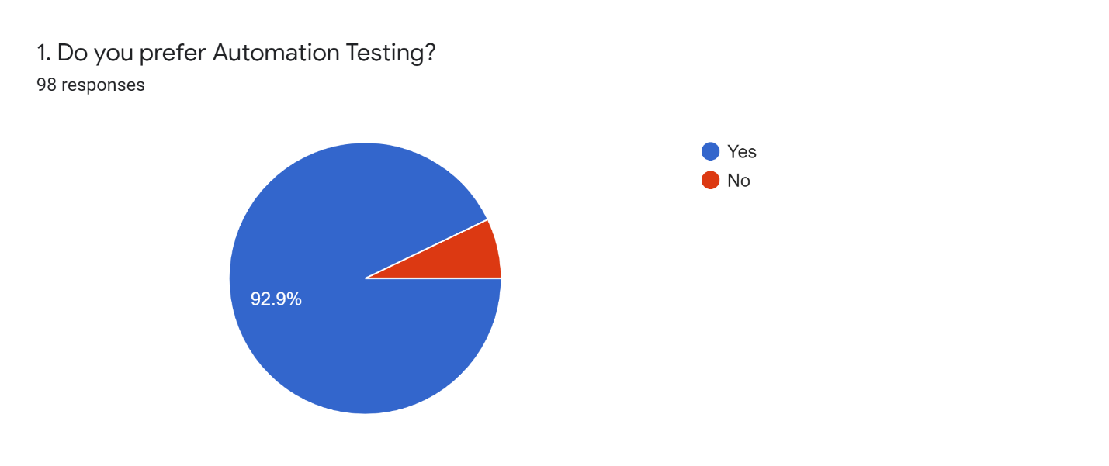
INFERENCE: From the above table, it is inferred that 92.9% of respondents prefer automation testing.

TABLE 4.7: WHEN DO YOU PREFER MANUAL TESTING OVER AUTOMATION TESTING
When do you prefer Manual testing over Automation testing
 |  | Frequency | Percent
Valid |  | 2 | 2.0
Valid | Ad-hoc or exploratory testing needs to be performed. | 6 | 6.1
Valid | Applications/module is newly developed and has no previous test cases. | 5 | 5.1
Valid | Applications/module is newly developed and has no previous test cases., Ad-hoc or exploratory testing needs to be performed. | 3 | 3.0
Valid | The project is short-term | 8 | 8.1
Valid | The project is short-term, Ad-hoc or exploratory testing needs to be performed. | 2 | 2.0
Valid | The project is short-term, Applications/module is newly developed and has no previous test cases. | 5 | 5.1
Valid | The project is short-term, Applications/module is newly developed and has no previous test cases., Ad-hoc or exploratory testing needs to be performed. | 4 | 4.0
Valid | The project is short-term, Usability testing needs to be performed. | 10 | 10.1
Valid | The project is short-term, Usability testing needs to be performed., Ad-hoc or exploratory testing needs to be performed. | 2 | 2.0
Valid | The project is short-term, Usability testing needs to be performed., Applications/module is newly developed and has no previous test cases. | 7 | 7.1
Valid | The project is short-term, Usability testing needs to be performed., Applications/module is newly developed and has no previous test cases., Ad-hoc or exploratory testing needs to be performed. | 20 | 20.2
Valid | Usability testing needs to be performed. | 7 | 7.1
Valid | Usability testing needs to be performed., Ad-hoc or exploratory testing needs to be performed. | 4 | 4.0
Valid | Usability testing needs to be performed., Applications/module is newly developed and has no previous test cases. | 10 | 10.1
Valid | Usability testing needs to be performed., Applications/module is newly developed and has no previous test cases., Ad-hoc or exploratory testing needs to be performed. | 4 | 4.0
Valid | Total | 99 | 100.0

FIGURE 4.7:
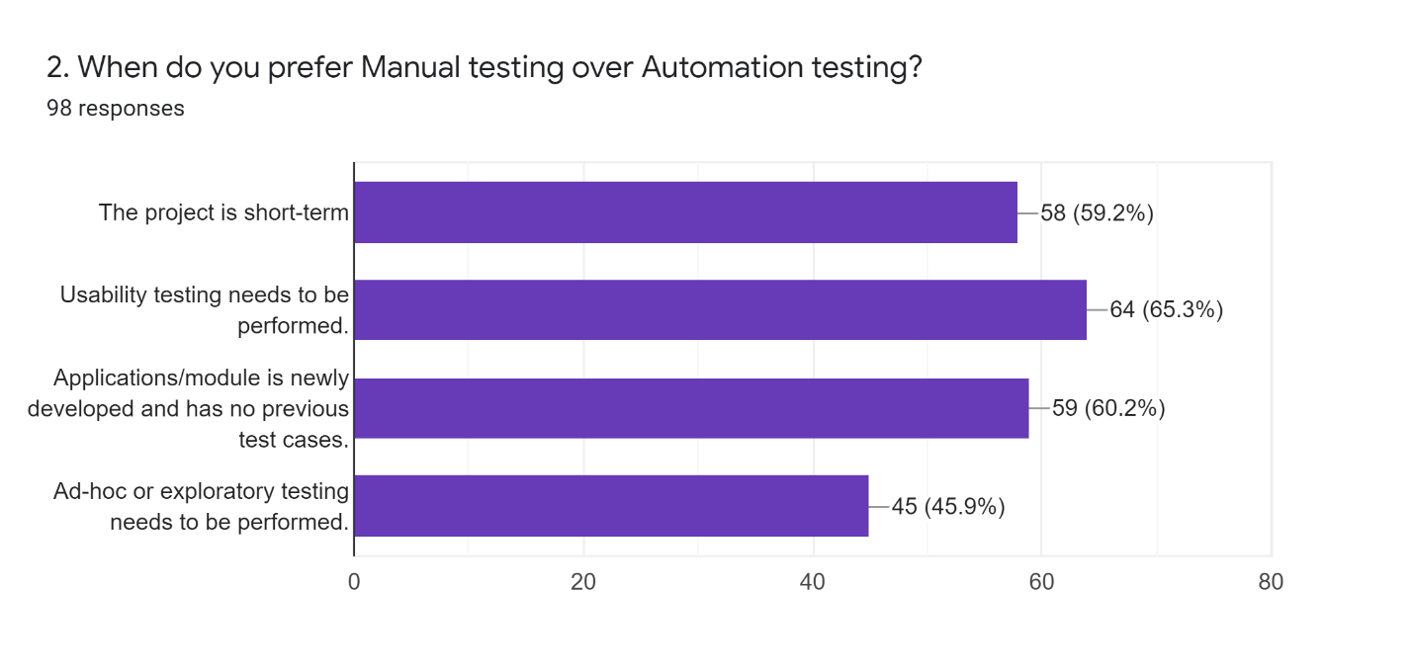
INFERENCE: From the above table, it is inferred that 65.3 % prefer manual testing over automation testing while usability testing is necessary/needs to be performed
TABLE 4.8: WHAT FACTORS DETERMINE THE EFFECTIVENESS OF AUTOMATION TESTING
What factors determine the effectiveness of Automation testing
 |  | Frequency | Percent
Valid |  | 2 | 2.0
Valid | Development time | 5 | 5.1
Valid | Development time, Quality of the software | 5 | 5.1
Valid | Development time, Test Reusability | 7 | 7.1
Valid | Development time, Test Reusability, Quality of the software | 2 | 2.0
Valid | Quality of the software | 4 | 4.0
Valid | Test Coverage | 3 | 3.0
Valid | Test Coverage, Development time | 2 | 2.0
Valid | Test Coverage, Development time, Quality of the software | 7 | 7.1
Valid | Test Coverage, Development time, Test Reusability | 5 | 5.1
Valid | Test Coverage, Development time, Test Reusability, Quality of the software | 20 | 20.2
Valid | Test Coverage, Quality of the software | 4 | 4.0
Valid | Test Coverage, Test Reusability | 7 | 7.1
Valid | Test Coverage, Test Reusability, Quality of the software | 14 | 14.1
Valid | Test Reusability | 8 | 8.1
Valid | Test Reusability, Quality of the software | 4 | 4.0
Valid | Total | 99 | 100.0

FIGURE 4.8:
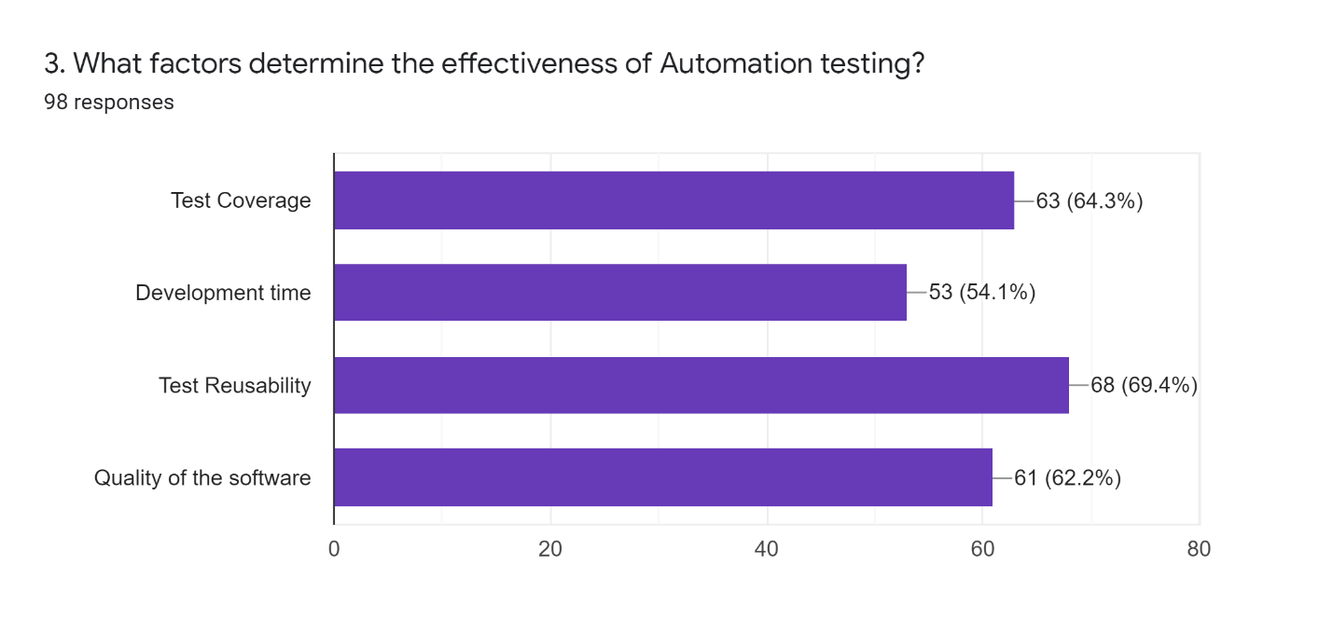
INFERENCE: From the above table, it is inferred that 69.4% of the people who attended the survey consider test reusability as a factor determining the effectiveness of Automation testing.

TABLE 4.9: MORE DEFECTS ARE IDENTIFIED IN WHICH LEVEL OF TESTING
More defects are identified in which level of testing
 |  | Frequency | Percent
Valid |  | 3 | 3.0
Valid | Acceptance Testing | 19 | 19.2
Valid | System Integration Testing | 35 | 35.4
Valid | Unit Testing | 19 | 19.2
Valid | Volume Testing/Performance Testing | 23 | 23.2
Valid | Total | 99 | 100.0

FIGURE 4.9:
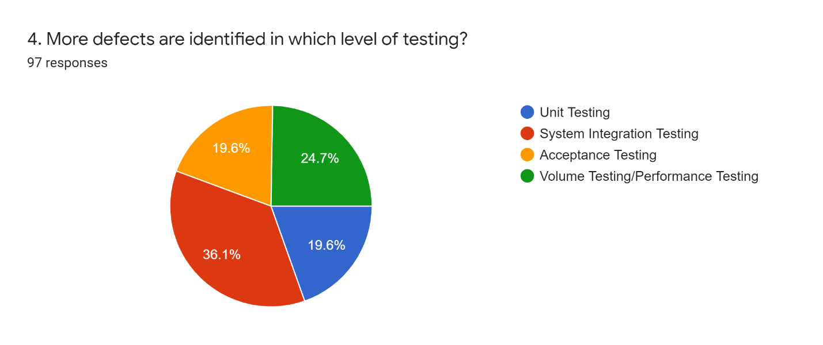

INFERENCE: From the above table, it is inferred that 36.1% of respondents prefer that more defects be identified in system integration testing.

TABLE 4.10: CAN YOU ACHIEVE 100 PERCENT IN AUTOMATION
Can you achieve 100 percent in automation
 |  | Frequency | Percent
Valid |  | 3 | 3.0
Valid | No | 74 | 74.7
Valid | Yes | 22 | 22.2
Valid | Total | 99 | 100.0

FIGURE 4.10:
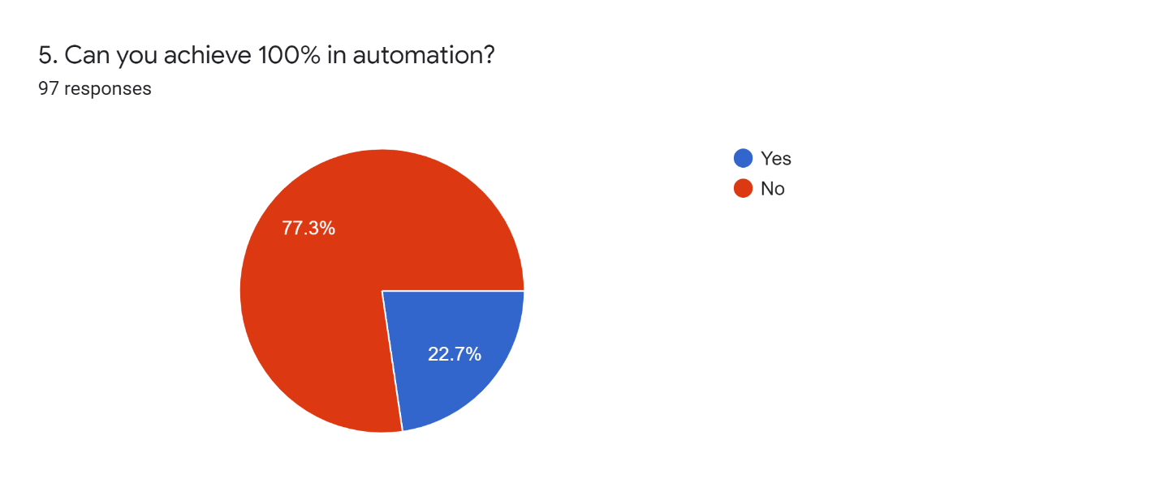

INFERENCE: From the above table, it is inferred that 77.3% of people who attended the survey believe it is not possible to attain 100% efficiency in automation.
TABLE 4.11: HOW DO YOU DECIDE WHICH TOOL YOU HAVE TO USE?
Decision of tool
 |  | Frequency | Percent
Valid |  | 3 | 3.0
Valid | Identify if you already have skilled resources for the tools. | 1 | 1.0
Valid | Identify your budget for the automation tool. | 4 | 4.0
Valid | Identify your budget for the automation tool., Identify if you already have skilled resources for the tools. | 1 | 1.0
Valid | Search for the list of tools that support your project’s requirements. | 9 | 9.1
Valid | Search for the list of tools that support your project’s requirements., Identify if you already have skilled resources for the tools. | 2 | 2.0
Valid | Search for the list of tools that support your project’s requirements., Identify your budget for the automation tool. | 4 | 4.0
Valid | Search for the list of tools that support your project’s requirements., Identify your budget for the automation tool., Identify if you already have skilled resources for the tools. | 2 | 2.0
Valid | Understand your project requirements | 7 | 7.1
Valid | Understand your project requirements, Identify if you already have skilled resources for the tools. | 4 | 4.0
Valid | Understand your project requirements, Identify your budget for the automation tool. | 8 | 8.1
Valid | Understand your project requirements, Identify your budget for the automation tool., Identify if you already have skilled resources for the tools. | 8 | 8.1
Valid | Understand your project requirements, Search for the list of tools that support your project’s requirements. | 9 | 9.1
Valid | Understand your project requirements, Search for the list of tools that support your project’s requirements., Identify if you already have skilled resources for the tools. | 2 | 2.0
Valid | Understand your project requirements, Search for the list of tools that support your project’s requirements., Identify your budget for the automation tool. | 13 | 13.1
Valid | Understand your project requirements, Search for the list of tools that support your project’s requirements., Identify your budget for the automation tool., Identify if you already have skilled resources for the tool | 22 | 22.2
Valid | Total | 99 | 100.0

FIGURE 4.11:
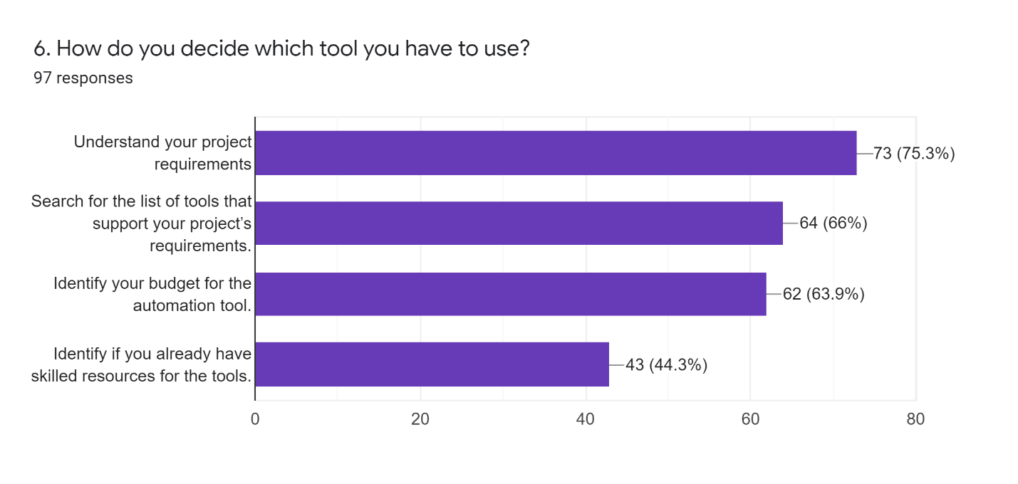

INFERENCE: Understanding your project needs is a factor in deciding the tool to be utilized, according to 75.3 percent of those who took the survey.
TABLE 4.12: WHAT KIND OF TEST DO YOU THINK SHOULD NOT BE AUTOMATED?
Test should not be automated
 |  | Frequency | Percent
Valid |  | 4 | 4.0
Valid | Exploratory testing | 8 | 8.1
Valid | Exploratory testing, Test which is executed quickly when done manually. | 5 | 5.1
Valid | Exploratory testing, Usability testing | 4 | 4.0
Valid | Exploratory testing, Usability testing, Test which is executed quickly when done manually. | 4 | 4.0
Valid | Test which is executed quickly when done manually | 1 | 1.0
Valid | Test which is executed quickly when done manually. | 9 | 9.1
Valid | Tests that are rarely executed. | 4 | 4.0
Valid | Tests that are rarely executed., Exploratory testing | 12 | 12.1
Valid | Tests that are rarely executed., Exploratory testing, Test which is executed quickly when done manually. | 4 | 4.0
Valid | Tests that are rarely executed., Exploratory testing, Usability testing | 5 | 5.1
Valid | Tests that are rarely executed., Exploratory testing, Usability testing, Test which is executed quickly when done manually. | 11 | 11.1
Valid | Tests that are rarely executed., Test which is executed quickly when done manually. | 10 | 10.1
Valid | Tests that are rarely executed., Usability testing | 4 | 4.0
Valid | Tests that are rarely executed., Usability testing, Test which is executed quickly when done manually. | 3 | 3.0
Valid | Usability testing | 5 | 5.1
Valid | Usability testing, Test which is executed quickly when done manually. | 6 | 6.1
Valid | Total | 99 | 100.0

FIGURE 4.12:
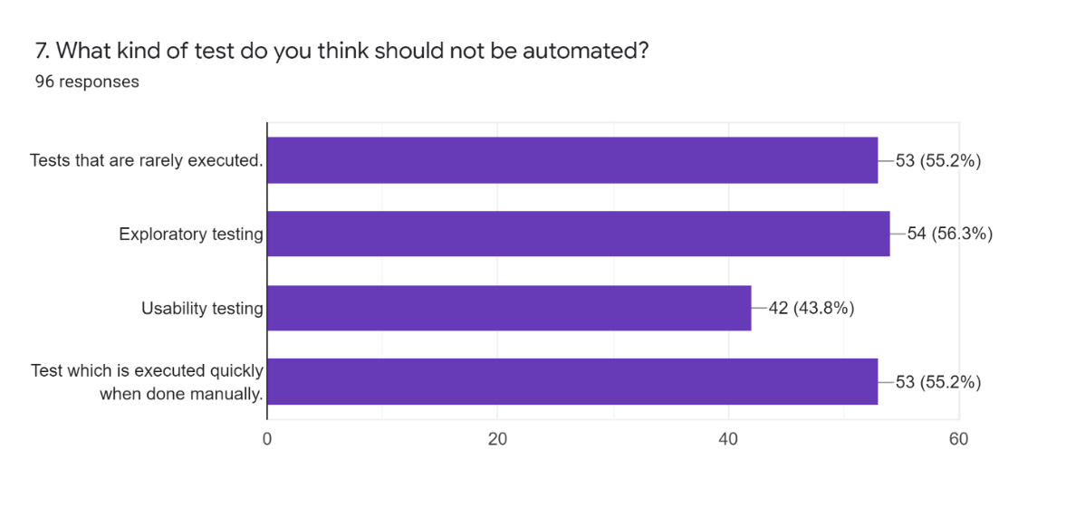
INFERENCE: According to 56.3% of individuals who responded to the study, exploratory testing is a type of test that should not be automated.
4.13: TESTING ONLY AT UI LEVEL
INFERENCE: From the analysis, it is inferred that 79.8% of the respondents disagree that testing can be done only at UI level and 20.2% of the respondents agree that testing can be done at UI level.
TABLE 4.14: AUTOMATION TESTING ESSENTIAL TO IDENTIFY BUGS
INFERENCE: From the analysis, it can be inferred that <10% of the respondents strongly disagree that automation is essential to identify bugs and 16.7% of the respondents are neutral and <10% of the respondents disagreed and 50% of the respondents have agreed and 26% of the respondents strongly agree. Most of the respondents agree that automation is essential to identify bugs.
TABLE 4.15: IDENTIFICATION OF DEFECTS CONCERNING DATA PRIVACY AND SECURITY IS HIGHLY IMPORTANT WHILE TESTING
Data Privacy And Security
 |  | Frequency | Percent
Valid | 2 | 2 | 2.0
Valid | 3 | 8 | 8.1
Valid | 4 | 46 | 46.5
Valid | 5 | 37 | 37.4
Valid | Total | 93 | 93.9
Missing | System | 6 | 6.1
Total |  | 99 | 100.0

FIGURE 4.15:
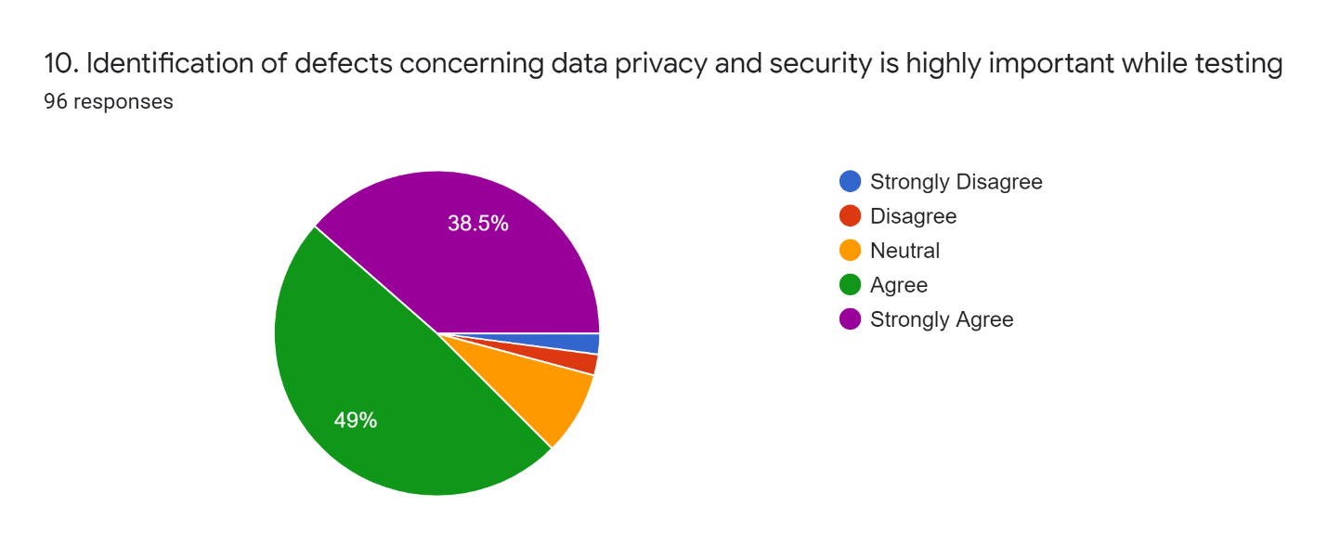
INFERENCE: From the analysis, it can be inferred that <10% of the respondents strongly disagree, <10% of the respondents are neutral, <10% of the respondents disagreed and 49% of the respondents have agreed and 38.5% of the respondents strongly agree. Most of the respondents agree that data privacy and security are highly important.
4.16: IDENTIFY DEFECTS WITH OUT OF THE BOX THINKING
INFERENCE: From the analysis, it can be inferred that <10% of the respondents strongly disagree, <10% of the respondents are neutral, <10% of the respondents disagreed and 34.8% of the respondents have agreed and 38.5% of the respondents strongly agree. Most of the respondents agree that out-of-the-box thinking is highly important.
4.17: NEGATIVE TESTING IDENTIFIES MORE DEFECTS THAN POSITIVE TESTING
INFERENCE: From the analysis, it can be inferred that <10% of the respondents strongly disagree and 19.8% of the respondents are neutral, and <10% of the respondents disagreed and 42.7% of the respondents have agreed and 31.3% of the respondents strongly agree. Most of the respondents agree that more defects are identified in negative testing.

4.18: DEVELOPERS FOCUS ONLY ON POSITIVE TESTING
INFERENCE: From the analysis, it can be inferred that <10% of the respondents strongly disagree and 16.1% of the respondents are neutral, and <10% of the respondents disagreed and 44.1% of the respondents have agreed and 31.2% of the respondents strongly agree. Most of the respondents agree that developers focus only on positive testing.
TABLE 4.19: DIFFERENT STAGES IN DETECTION OF DEFECTS
Different Stages In Detection Of Defects
 |  | Frequency | Percent | Valid Percent | Cumulative Percent
Valid | 1 | 4 | 4.0 | 4.2 | 4.2
Valid | 2 | 2 | 2.0 | 2.1 | 6.3
Valid | 3 | 6 | 6.1 | 6.3 | 12.6
Valid | 4 | 31 | 31.3 | 32.6 | 45.3
Valid | 5 | 52 | 52.5 | 54.7 | 100.0
Valid | Total | 95 | 96.0 | 100.0
Missing | System | 4 | 4.0
Total |  | 99 | 100.0
FIGURE 4.19:
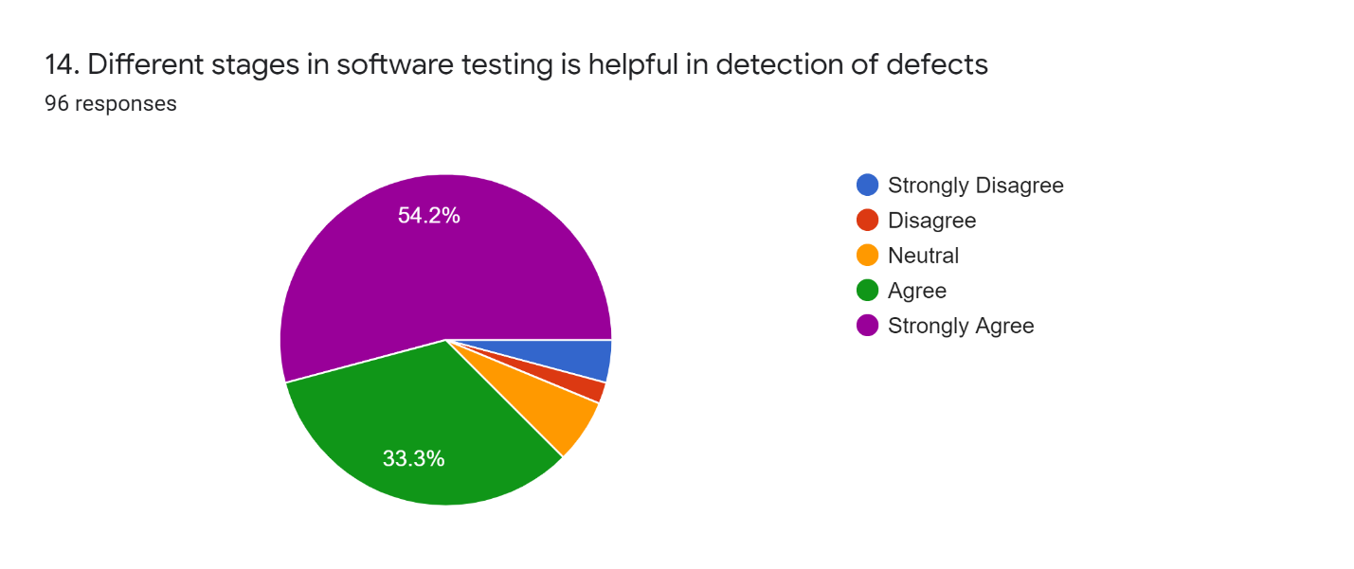

INFERENCE: From the above table, it can be inferred that <10% of the respondents strongly disagree, <10% of the respondents are neutral, and <10% of the respondents disagreed and 33.3% of the respondents have agreed and 54.2% of the respondents strongly agree. Most of the respondents strongly agreed that different stages in software testing are helpful in detecting the bugs earlier
4.20: TO TEST SOFTWARE EFFECTIVELY, WE NEED TO CONSIDER OURSELVES AS END-USERS
INFERENCE: From the analysis, it can be inferred that <10% of the respondents strongly disagree, 10% of the respondents are neutral, and <10% of the respondents disagreed and 16.8% of the respondents have agreed and 67.4% of the respondents strongly agree. Most of the respondents strongly agree that testers need to consider themselves as end-users.
4.21: COMMUNICATION ACROSS THE TESTING AND DEVELOPMENT TEAM ALONG WITH THE DOMAIN EXPERTS IMPROVES THE QUALITY OF SYSTEMS DELIVERED
INFERENCE: From the analysis, it can be inferred that <10% of the respondents strongly disagree and 16.1% of the respondents are neutral, and <10% of the respondents disagreed and 44.1% of the respondents have agreed and 31.2% of the respondents strongly agree. Most of the respondents strongly agree that communication across the testing and development team along with the domain experts improves the quality of systems delivered.
4.22: FLEXIBILITY OF INTEGRATING FUNCTIONAL MODULES
INFERENCE: From the analysis, it can be inferred that <9% of the respondents disagree and 9.5% of the respondents are Neutral and 41.1% of the respondents have agreed and 43.2% of the respondents strongly agree that the flexibility of integrating functional modules is very important in automation testing.
TABLE 4.23: PROCESS IMPROVEMENT
Process Improvement
 |  | Frequency | Percent
Valid |  | 4 | 4.0
Valid | Agree | 45 | 45.5
Valid | Disagree | 5 | 5.1
Valid | Neutral | 9 | 9.1
Valid | Strongly Agree | 31 | 31.3
Valid | Strongly Disagree | 5 | 5.1
Valid | Total | 99 | 100.0

FIGURE 4.23:
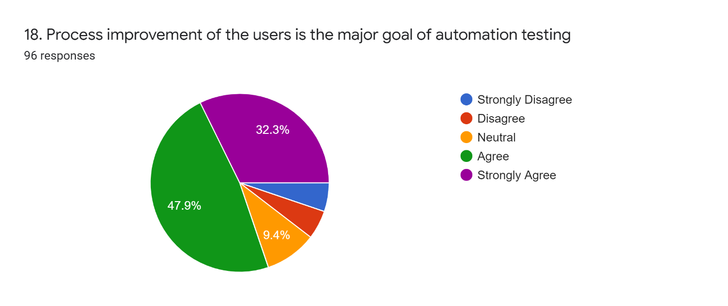
INFERENCE: It is inferred that <9% of the respondents disagree and 9.4% of the respondents have responded Neutral and 32.3% of the respondents have strongly agreed and 43.2% of the respondents agree that the project improvement of the users is the major goal.
4.24: ENHANCED SECURITY OF THE PROCESS HAS TO BE MAINTAINED DURING AUTOMATION TESTING
Enhanced Security
 |  | Frequency | Percent
Valid |  | 4 | 4.0
Valid | Agree | 39 | 39.4
Valid | Disagree | 3 | 3.0
Valid | Neutral | 9 | 9.1
Valid | Strongly Agree | 39 | 39.4
Valid | Strongly Disagree | 5 | 5.1
Valid | Total | 99 | 100.0

FIGURE 4.24:
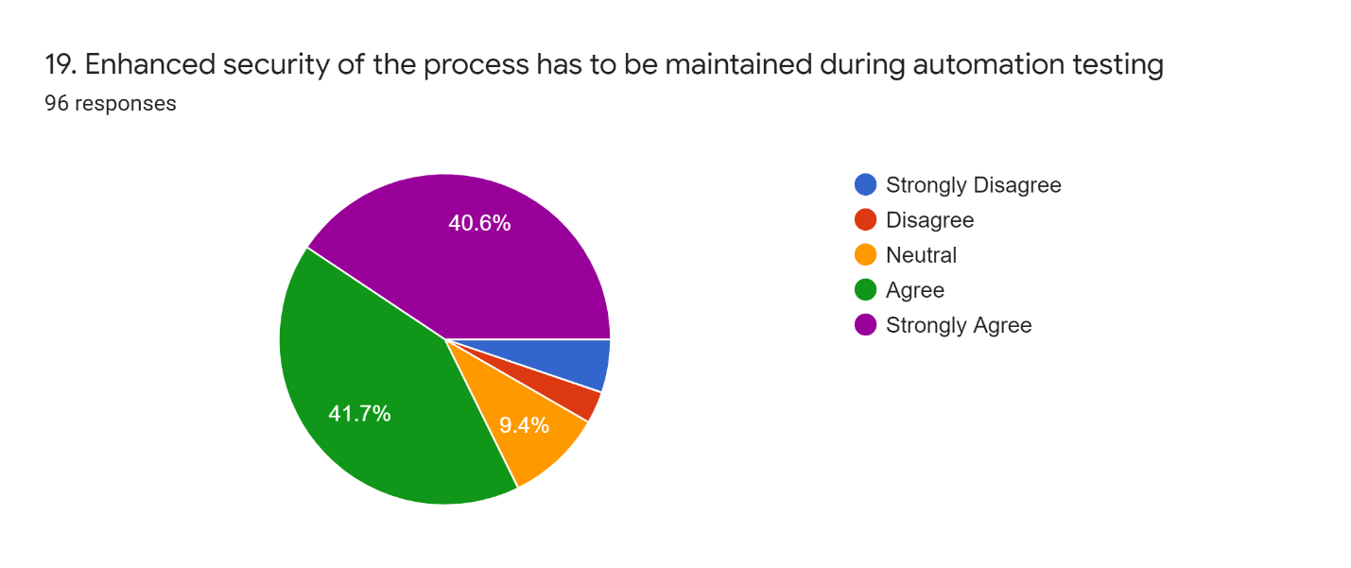

INFERENCE: From the above table, it can be inferred that <10% of the respondents disagree and 9.4% of the respondents are Neutral and 41.7% of the respondents have agreed and 40.6% of the respondents strongly agree. Most of the respondents agree that enhanced security of the process should be maintained.

4.2 STATISTICAL TOOLS AND ANALYSIS
ANALYSIS USING KARL PEARSON’S CORRELATION
Correlation analysis is the statistical tool used to measure the degree to which two variables are linearly related to each other. Correlation measures the degree of association between two variables.
Null hypothesis (H0):
There is a positive relationship between the detection of defects concerning data privacy and security.
Alternate hypothesis (H1):
There is a negative relationship between the detection of defects concerning data privacy and security.
Correlations
 |  | DataPrivacyAndSecurity | DetectionOfDefects
DataPrivacyAndSecurity | Pearson Correlation | 1 | .431**
DataPrivacyAndSecurity | Sig. (2-tailed) |  | <.001
DataPrivacyAndSecurity | N | 117 | 117
DetectionOfDefects | Pearson Correlation | .431** | 1
DetectionOfDefects | Sig. (2-tailed) | <.001
DetectionOfDefects | N | 117 | 114
**. Correlation is significant at the 0.01 level (2-tailed).

CONCLUSION: Since the result of the P-value is <0.001 hence it is highly significant. So we reject the null hypothesis at 1% of the level.
CHI- SQUARE TEST I – (ψ²)
Case Processing Summary
 | Cases
 | Valid |  | Missing |  | Total
 | N | Percent | N | Percent | N | Percent
Automation Testing * Domain Experience | 117 | 100.0% | 0 | 0.0% | 117 | 100.0%

Automation Testing * Domain Experience Cross tabulation
 |  |  | Domain Experience
 |  |  |  | 2-5 year | 5-10 yea | Above 10 | Less than
Automation  Testing |  | Count | 0 | 0 | 0 | 0 | 1
Automation  Testing |  | Expected Count | .1 | .2 | .1 | .0 | .6
Automation  Testing | No | Count | 0 | 1 | 1 | 1 | 4
Automation  Testing | No | Expected Count | .5 | 1.7 | .5 | .3 | 4.0
Automation  Testing | Yes | Count | 7 | 22 | 6 | 3 | 51
Automation  Testing | Yes | Expected Count | 6.4 | 21.1 | 6.4 | 3.7 | 51.4
Total |  | Count | 7 | 23 | 7 | 4 | 56
 |  | Expected Count | 7.0 | 23.0 | 7.0 | 4.0 | 56.0

Automation Testing * Domain Experience Cross tabulation
 |  |  | Total
Automation Testing |  | Count | 1
Automation Testing |  | Expected Count | 1.0
Automation Testing | No | Count | 7
Automation Testing | No | Expected Count | 7.0
Automation Testing | Yes | Count | 99
Automation Testing | Yes | Expected Count | 89.0
Total |  | Count | 117
 |  | Expected Count | 117.0

Chi-Square Tests
 | Value | df | Asymptotic Significance (2-sided)
Pearson Chi-Square | 3.981ª | 8 | .859
Likelihood Ratio | 4.104 | 8 | .848
N of Valid Cases | 97
a. 11 cells (73.3%) have an expected count of less than 5. The minimum expected count is .04.

Symmetric Measures
 |  | Value | Approximate Significance
Nominal by Nominal | Phi | .203 | .859
Nominal by Nominal | Cramer's V | .143 | .859
N of Valid Cases |  | 117

CHAPTER 5
5.1 FINDINGS
- Respondents prefer manual testing over automation testing only when usability testing needs to be performed and when the application has no previous test cases.
- One of the key factors that impact the quality of software according to respondents is the development time.
- Test coverage will help to increase software quality.
Respondents choose the reusability of tests to perform automation more effectively.
According to respondents, manual testing cannot be replaced completely over automation testing.
- Automating tools should be in a user-friendly mode, with only a few options for running the script.
- When trying to test new applications, they should be adapted to any language.
- It should be able to properly detect failure scenarios and give ideas for overcoming the failures.
- It should also be simple to comprehend.

5.2 SUGGESTIONS
- Write tests
The first step to API testing is to actually do it. Without good tests, it’s impossible to have full confidence in your API’s behavior, consistency, or backward compatibility. As your codebase grows and changes over time, tests will save you time and frustration by spotting breaking changes.
- Don’t mix tests and documentation
Many people use Postman Collections to document their APIs, either as a collection of example requests that can be easily shared among team members or as public API documentation for customers. For both of those use cases, it makes sense for your collection to contain detailed explanations for each of your API endpoints, walkthroughs of common API workflows, authentication requirements, lists of possible error responses, etc.
API tests, on the other hand, serve an entirely separate purpose. First of all, the audience is different. Whereas API documentation is for the consumers of an API, tests are for the authors of an API.
Secondly, the content is different. A solid test suite will include many edge cases, intentional bad inputs (to test the error handling), and possibly reveal sensitive information, all of which would be irrelevant or confusing for your API’s consumers.
And finally, the authors are possibly different. Documentation (especially public docs) may be written by your marketing team or technical writers, whereas tests are written by the developers who built the API or the testers who are responsible for validating the API.
- Organize tests into folders
As your API grows in complexity, it will become important to organize your tests so they make sense and can be found easily. I suggest that you use folders to group requests by resource, test suite, and workflows.
- Resources:
Create a top-level folder for each of your API’s resources (users, orders, products, etc.).
- Test Suites:
The second-level folders would be test suites for each of those resources, such as “Start a new order “, “Edit an existing order“, “Cancel an order“, etc.
For simple tests that only require a single API call, there’s no need for a third level of folders. You can simply create requests directly under the test suite folder. Be sure to give your requests meaningful names to differentiate them and describe what they’re testing. For example, the “Edit an existing order” test suite folder might contain requests such as “Add a product“, “Remove a product“, “Change the shipping address“, etc.
- Workflows:
The third-level folders are for more complicated tests that span multiple API calls. For example, your API might have a checkout flow that involves separate calls to create an order from a shopping cart, enter the shipping address, select the shipment method, and submit the payment information. In this case, you’d create a “workflow” folder named something like “Checkout” that contains the three requests.
- JSON Schema validation
Many modern APIs use some form of JSON Schema to define the structure of their requests and responses. Postman includes the tv4 library, which makes it easy to write tests to verify that your API responses comply with your JSON Schema definitions.
Of course, you probably wouldn’t want to hard code your JSON Schema in your test script, especially since you may need to use the same schema for many requests in your collection. So, instead, you could store the schema as a JSON string in a Postman environment variable. Then you can simply use the variable in your test script, like this:
- Reuse code
In the previous tip, I showed you how to easily reuse the same JSON Schema for multiple requests in your collection by storing it in an environment variable. You can also reuse JavaScript code the same way by leveraging the eval() function.
Most APIs have some common rules that apply to most (or all) endpoints. Certain HTTP headers should always be set, or the response body should always be in a certain format, or the response time must always be within an acceptable limit. Rather than re-writing these tests for every request, you can write them once in the very first request of your collection and reuse them in every request after that.
There’s no limit to the amount of code that can be stored in a variable and reused this way. In fact, you can use this trick to reuse entire JavaScript libraries, including many third-party libraries from NPM, Bower, and GitHub.

- Postman BDD
Postman’s default test syntax is really straightforward and easy to learn, but many people prefer the syntax of popular JavaScript test libraries such as Mocha and Chai. I happen to be one of those people, which is why I created Postman BDD. Postman BDD allows you to write Postman tests using Mocha’s BDD syntax. It leverages the “reusable code” trick from the previous tip to load Chai and Chai-HTTP, which means you can write tests like this:
In addition to the fluent syntax, Postman BDD has several other features and benefits that make Postman tests even easier and more powerful. Follow the installation instructions or check out the sample collection to get started.
- Automate your tests with Postman’s collection runner
Up to now, we’ve focused on running a single request and testing the response. That approach works great while you’re writing your tests, but once they’re all written, you’ll want an easy way to run all of your requests quickly and see the results in a single view. That’s where Postman’s collection runner comes in.
- Automate your tests with Newman
The Postman collection runner is a great way to run all of your tests and see the results, but it still requires you to manually initiate the run. If you want to run your Postman tests as part of your Continuous Integration or Continuous Delivery pipeline, then you’ll need to use the Newman CLI.
.Newman can easily be integrated into Jenkins, AppVeyor, Bamboo, CodeShip, Travis CI, Circle CI, or any other code deployment pipeline tool. It supports a variety of output formats, including a human-friendly console output, as well as outputting to a JSON or HTML file.
- Automate your tests with Postman Monitors
We can use Postman Monitors to automatically run our Postman tests at regular intervals, such as every night, or every 5 minutes. We’ll automatically be notified if any of your tests ever fail, and you can even integrate with a variety of third-party services, such as PagerDuty, Slack, Datadog, and more.
Postman Monitors shows your test results in the same familiar layout as the Postman collection runner, so it’s easy to compare the results to the Postman app.
- Dynamically control test workflows
By default, the Postman collection runner, Newman, and Postman Monitors will run each request in your collection in order. But you can use the postman.setNextRequest() function to change the order. This allows you to conditionally skip certain requests, repeat requests, terminate the collection early, etc.

5.3 CONCLUSION
Test automation, in the author's opinion, is the best and easiest way to execute software testing. The benefits of test automation include the software's reusability and the ease with which all test scripts can be documented and maintained. Manual testing, however, should not be completely eliminated from any organization's test plan, according to the author. The success of the QA process is dependent on understanding the underlying objective of testing and the available approaches that may be used to enhance effective testing. Calculating the return on investment is the most popular technique to assess the success of test automation (ROI). Profit divided by expenses is the profit-to-expense ratio.
Manual testing can also be useful in terms of saving time and money. Test automation, on the other hand, isn't always used to save money or resources. For a variety of reasons, the speed with which tests are completed might be critical to a company's success. Precisely in these cases, automation helps save not money but time.
Another motivation is to avoid human errors while testing systems that demand a high level of accuracy and precision. The cost of such errors can be much larger than the expense of developing and maintaining automated tests.

APPENDIX
QUESTIONNAIRE
A STUDY ON THE EFFECTIVENESS OF AN AUTOMATED TESTING TOOL

Email *

Gender
A. Male
B. Female

Domain Experience
A. Less than 2 years
B. 2-5 years
C. 5-10 years
D. Above 10 years

Overall Experience
A. Less than 2 years
B. 2-5 years
C. 5-10 years
D. Above 10 years

Qualification
A. UG
B. PG
C. Other:

Designation

1. Do you prefer Automation Testing?
A. Yes
B. No

2. When do you prefer Manual testing over Automation testing?
A. The project is short-term
B. Usability testing needs to be performed.
C. Applications/module is newly developed and has no previous test cases.
D. Ad-hoc or exploratory testing needs to be performed.

3. What factors determine the effectiveness of Automation testing?
A. Test Coverage
B. Development time
C. Test Reusability
D. Quality of the software

4. More defects are identified in which level of testing?
A. Unit Testing
B. System Integration Testing
C. Acceptance Testing
D. Volume Testing/Performance Testing

5. Can you achieve 100% in automation?
A. Yes
B. No

6. How do you decide which tool you have to use?
A. Understand your project requirements
B. Search for the list of tools that support your project’s requirements.
C. Identify your budget for the automation tool.
D. Identify if you already have skilled resources for the tools.

7. What kind of test do you think should not be automated?
A. Tests that are rarely executed.
B. Exploratory testing
C. Usability testing
D. Test which is executed quickly when done manually.

8. Do you think that testing can be done only at the UI level?
A. Yes
B. No

9. Automation testing is essential to identify bugs effectively
A. Strongly Disagree
B. Disagree
C. Neutral
D. Agree
E. Strongly Agree

10. Identification of defects concerning data privacy and security is highly important while testing
A. Strongly Disagree
B. Disagree
C. Neutral
D. Agree
E. Strongly Agree

11. Identify defects with out of the box thinking more vigorously
A. Strongly Disagree
B. Disagree
C. Neutral
D. Agree
E. Strongly Agree

12. Negative testing identifies more defects than positive testing
A. Strongly Disagree
B. Disagree
C. Neutral
D. Agree
E. Strongly Agree

13. Developers focus only on positive testing
A. Strongly Disagree
B. Disagree
C. Neutral
D. Agree
E. Strongly Agree

14. Different stages in software testing is helpful in detection of defects
A. Strongly Disagree
B. Disagree
C. Neutral
D. Agree
E. Strongly Agree

15. To test software effectively, we need to consider ourselves as end-users
A. Strongly Disagree
B. Disagree
C. Neutral
D. Agree
E. Strongly Agree

16. Communication across the testing and development team along with the domain experts improves the quality of systems delivered
A. Strongly Disagree
B. Disagree
C. Neutral
D. Agree
E. Strongly Agree
17. The flexibility of integrating functional modules is very important in automation testing
A. Strongly Disagree
B. Disagree
C. Neutral
D. Agree
E. Strongly Agree

18. Process improvement of the users is the major goal of automation testing
A. Strongly Disagree
B. Disagree
C. Neutral
D. Agree
E. Strongly Agree

19. Enhanced security of the process has to be maintained during automation testing
A. Strongly Disagree
B. Disagree
C. Neutral
D. Agree
E. Strongly Agree

20. Any suggestions to improve the effectiveness of the automated testing tool

BIBLIOGRAPHY
1. Sampling Theory for Forest Inventory | SpringerLink
2. (PDF) Chapter 3 - Research Methodology and Research Method (researchgate.net)
3. Software Test Automation: Effective Use of Test Execution Tools by Mark Fewster (goodreads.com)

REFERENCE
Theory and Methods of Sampling Techniques” by Mukhopadhyay and Parimal in DASFAA Conference, pages 291–305, 2020.
Sampling Theory: Beyond Bandlimited Systems” by Yonina C Eldar in ICDE Conference, pages1264–1275, 2021.
A Guide to Chi-Squared Testing: 280 (Wiley Series in Probability and Statistics) by Priscilla E. Greenwood, 2006

